INSTURCTIONS

The toolkit includes:

-Main suction box

-1 grid

-2 fixing bracket

-2 Drawers with Dust Filters (one is gray, another is white)

-1 adaptor with power cord

-Screws

Technical specifications:

Rated voltage: 220V 50-60Hz

Rated power: 100W

Air volume: 540m3 / h

Power supply specifications:

In: CA100-240v 50-60Hz

Outlet: CC12V 8.5A

Maximum speed: 4500 rpm

Dimension for main machine: 40cm(Length) /27.5cm(width) / 6.5cm(height)

Dimension with two fixing brackets: 58cm(Length) /27.5cm(width) / 6.5cm(height)

Gross weight: 4kg

Installation:

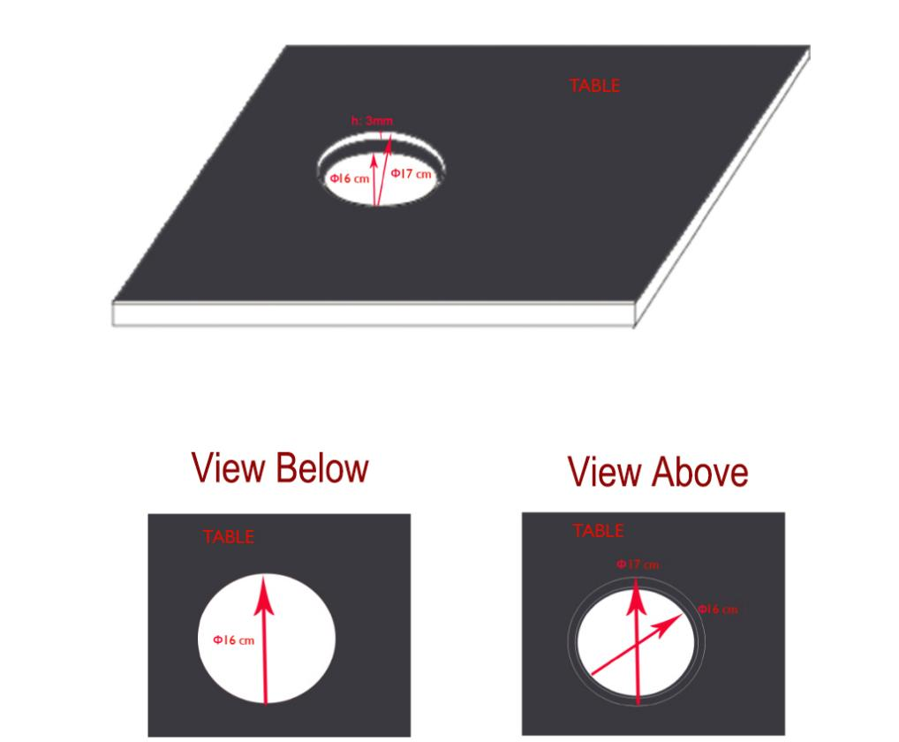

Grid installation

The table must be penetrated in the form of a diameter 17cm circle.

Note: this main circle is only 3 mm deep.

In order to prevent the grid from passing through the work plan from one side, a second smaller circle ("16 cm diameter") must be foreseen through the table.

Suction device installation

Matching the two fixing brackets with the main suction, fix them with 4 screws each, fix the main suction with other 8 screws under the table, be noted that the filter in the main suction must just be below the grid.

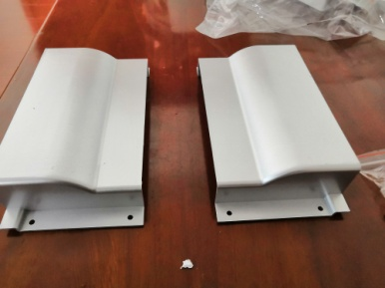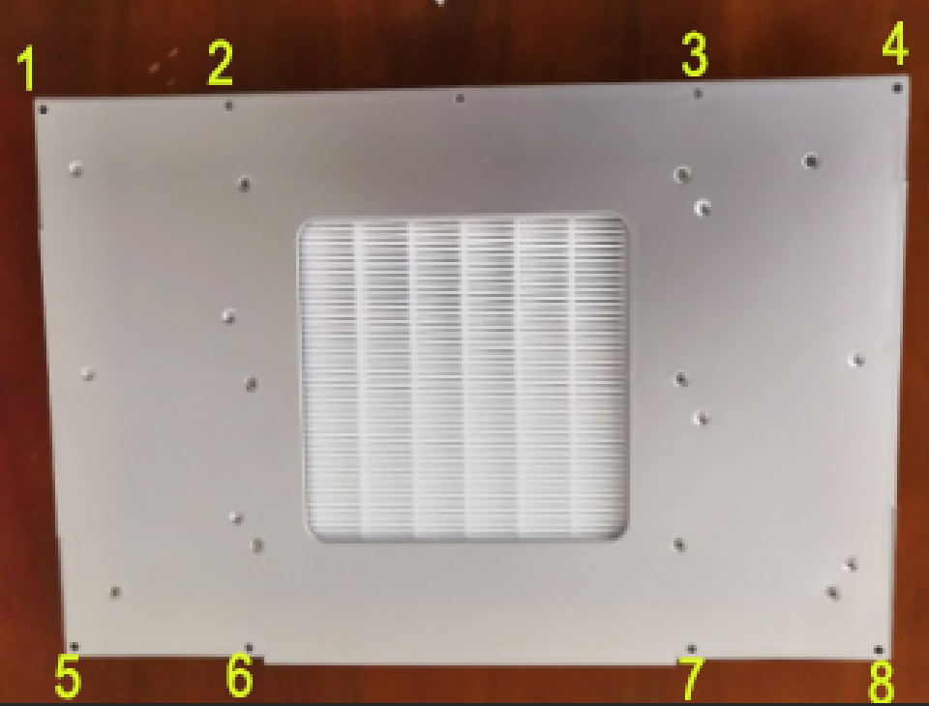

Two fixing brackets(4 screws per bracket) Suggesting screws distribution for the main suction

Overall Plan

